Curriculum Vitae

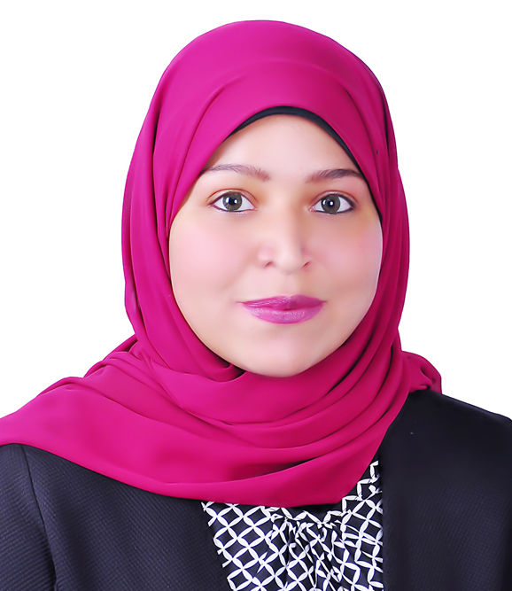
Name: Zeinab Ibrahim Rashed
Date of Birth: 1/1/1996
Gender: Female
Religion: Muslim
Nationality: Egyptian
Address: Luxor, Egypt.
Contact address: Department of Microbiology and Immunology, Faculty of Pharmacy, Assiut University.
E-mail: zinarashed111@gmail.com
Zeinab_Rashed@pharm.aun.edu.eg
Language: English, Arabic
Academic Qualifications:
- Bachelor in Pharmacy, Faculty of Pharmacy, Assiut University in 2019. Excellence with honor
- Demonstrator at Microbiology and Immunology Department, Faculty of Pharmacy, Assiut University.
Grade:
Demonstrator at Microbiology and Immunology Department Faculty of Pharmacy, Assiut University.
Computer Skills:
1- Microsoft Office.
2- Molecular Operating Environment.
3- Chemdraw.

